DARTMOUTH POLICE DEPARTMENT

FOR IMMEDIATE RELEASE: Sunday, October 23, 2016

Dartmouth Police Arrest Fairhaven Man on Narcotics Charges

DARTMOUTH, MA - On Friday, October 21, 2016, Dartmouth Police Department Detectives arrested Zachary NICKERSON (20) of 33 Whisper Lane, Fairhaven, MA on narcotics charges.

As a result of the arrest, 8 ounces of marijuana was seized.

NICKERSON was charged with Possession of a Class D Substance with the Intent to Distribute.

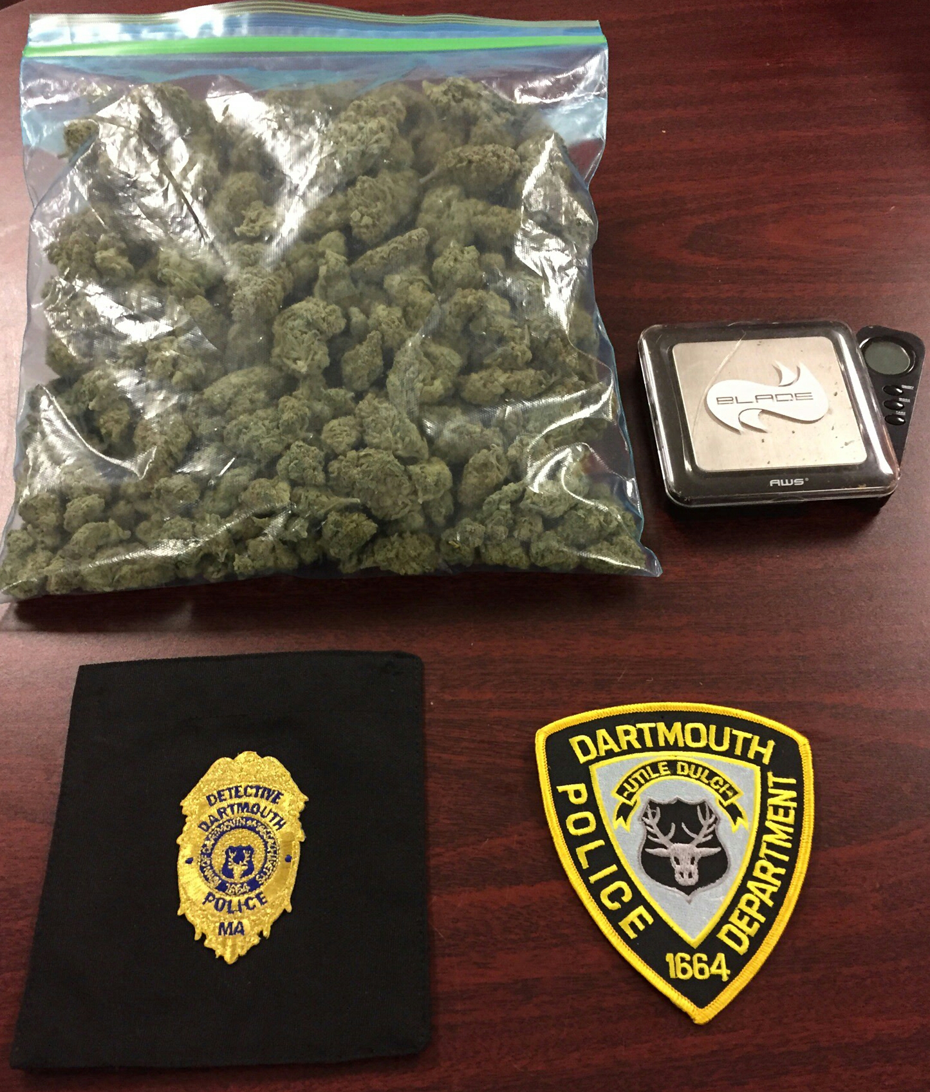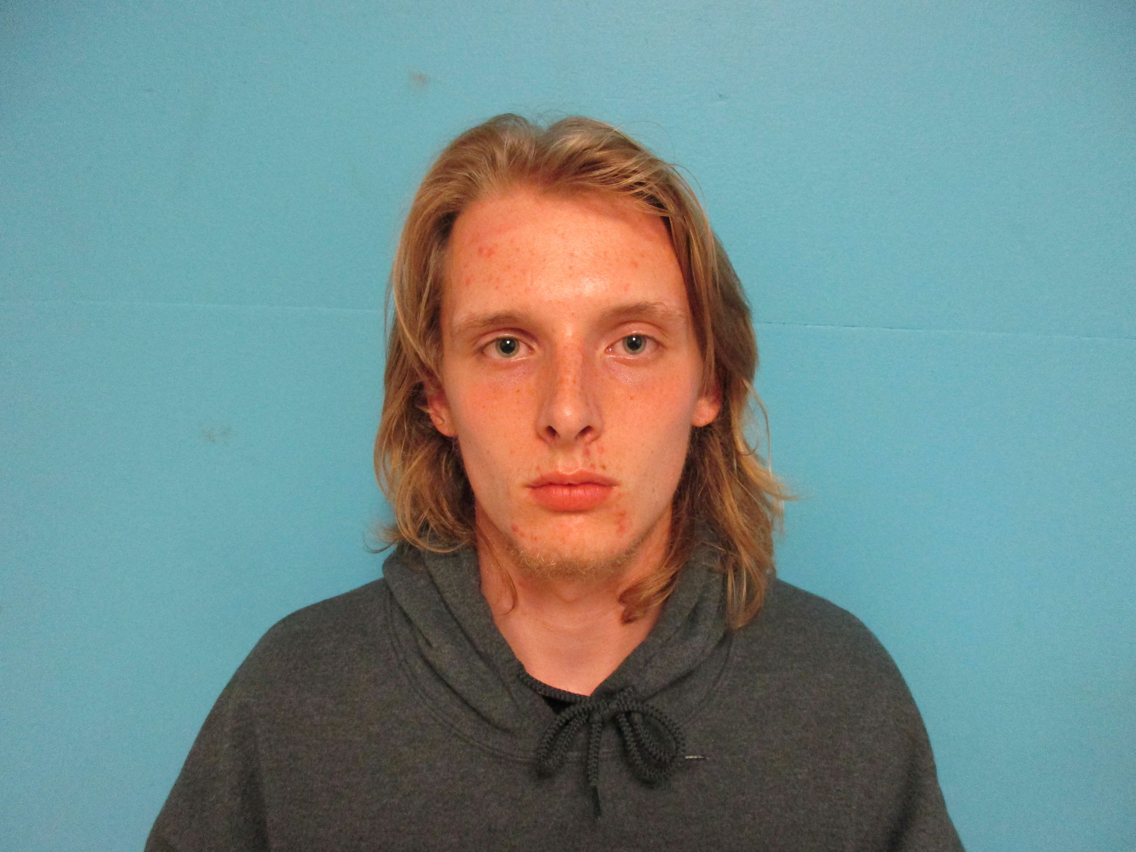

Contact: Detective Kyle Costa
Public Information Officer
774-930-0141

